(Approx. 2,572 words)

Crypto Simulation
By Dick Maybach, Member, Brookdale Computer Users’ Group, NJ
September 2016 issue, BUG Bytes
www.bcug.com
n2nd (at) att.net

Most children are fascinated by encryption; certainly, I was. I still remember having to ask my dad for help in learning to use my Captain Midnight Code-O-Graph, which encoded messages by replacing letters with numbers. Given the popularity of documentaries and movies about the British efforts to decode German Enigma messages during World War II, many adults, including me, retain this interest. Understanding modern encryption requires a sophisticated math background, and slogging through a description can be truly tedious. The simple mechanical devices used during World War II are more approachable and have much historical interest. A fascinating way to learn about them is to run simulations on your PC. You can follow the same procedures and tap the same keys that WWII German and American soldiers did, and by doing so obtain a much better understanding of the processes than by watching a movie or reading a book.

The Enigma is probably the most famous cryptographic device ever. Not only was it effective at the time, but it also significantly influenced World War II. Thousands died as a result of the successes and failures of attempts to decrypt messages encoded by it. The best way to learn about Enigma is to use one. While actual units are available, they are expensive. Instead, you can download an excellent free simulator from http://users.telenet.be/d.rijmenants/index.htm, a site in Belgium maintained by Dirk Rijmenants. Here you can find simulators for several historic crypto machines, instructions for using them, and their histories. These are Windows programs, but OS X users can run them using Crossover and Linux users with Wine. Like all similar devices of that era, the Enigma is a mechanical device, which used a set of disks to scramble the connections between the 26 letter keys of a keyboard and 26 lamps. At least one disk moved at each key press, so that pressing the same key twice produced two different output letters. A battery was needed only to illuminate the lamps. Mechanical connections between the keys and the rotors moved the latter.

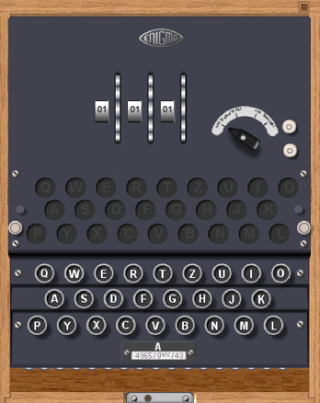
Screen 1. Enigma Panel.

Screen 1 shows the keyboard, the (unlit) output indicator lamps, the edges of the three rotors, the power switch, and the terminals for external power. There are some complications, but basically the operator selected three (of the five available) rotors and inserted them in the correct order. Then he rotated them to a given starting position and began typing. The indicator lamps remained lit only while the key was pressed, and a second operator was needed to record the output.

Screen 2 shows the same machine with its cover lifted. The three installed rotors are at the top and the two unused ones in a rack at the bottom. The unused rotors were stored in a separate box, which the simulator shows sitting on top of the keyboard mechanism. The empty space to the right of the rotors is for the battery.

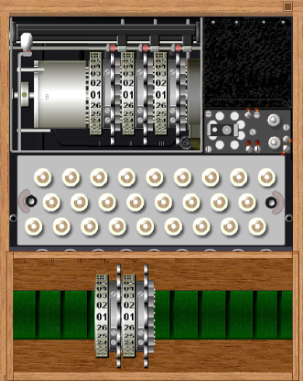
Screen 2. Enigma Interior.

A further complication was provided by a plugboard, Screen 3, that scrambled the connections between the keyboard and rotors. The simulator also includes this feature to allow setting the Enigma up exactly as it was used.

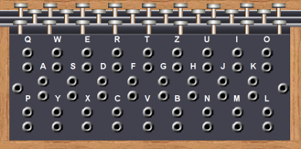
Screen 3. Enigma Plugboard.

Enigma was really a family of devices. Screen 4 shows a model used by the German navy. It had no internal battery, and used a plug instead of screw terminals for power.

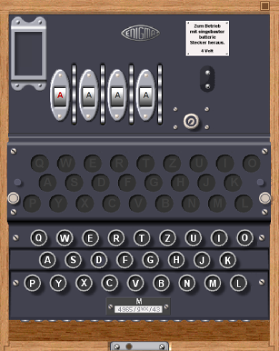
Screen 4. Enigma Model Used by the German Navy.

This used four rotors instead of three, and as a result was more secure.

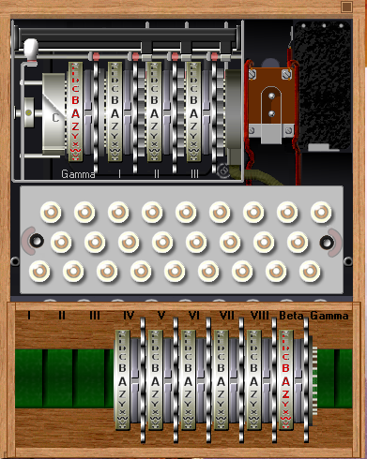
Screen 5. Interior of the Navy Enigma.

As shown in Screen 5, navy operators had more rotors to choose from, although only the Beta and Gamma units (those with red letters) could be used in the fourth slot.

To see how the Enigma was used, let's work through an example. The first step is to consult a codebook, Screen 6, for the machine settings of the day. There was a separate page for each month, with a line for each day (Tag in German). Using the sample, we see that for the 30th of this month we are to use rotors I, V, and VI, with offsets of 13, 23, and 02, respectively. The offset is how much the rotor should be rotated with respect to its outer numbered shell. (If you download the Enigma simulator, be sure also to get the Enigma Code Book Tool, which generated this example.)

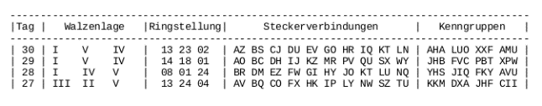
Screen 6. Enigma Codebook Sample.

Screen 7 shows a rotor I removed from the case (by right-clicking on it) and offset by 13 (with repeated clicks on the upper part of the rotor). We'll put it back in the case by right-clicking on the empty position and then set rotors V and IV similarly.

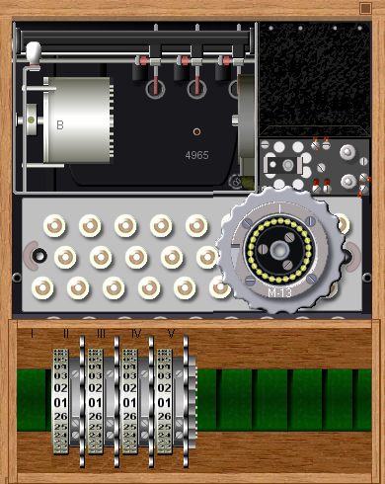
Screen 7. Enigma Being Configured.

The Steckerverbindungen column shows the plugboard connections. It tells us to swap A with Z, B with S, and so on. On the simulator, click on the lower edge of the keyboard to show the panel, Screen 8. (Note that the jacks are arranged like a QWERTY keyboard.) On the actual machine, A and Z would be swapped by connecting the A and the Z jacks with a cord; on the simulator, just click first on A then on Z. The screen-shot shows the panel set-up complete. Note that the A-jack pair is covered with a black shape labeled Z and that the Z pair has a shape labeled A. This is true for all 10 swaps called for in the codebook.

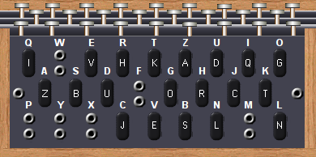
Screen 8. Configured Plugboard.

The simulator provides a check of the setup -- shown in Screen 9. It shows we've used a B reflector (the cylinder to the left of the rotors and the only one available for this model), the arrangement of the rotors, their offsets, and the plug settings. It also allows us to save the settings for later use.

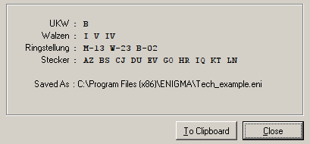
Screen 9. Enigma Simulator Check Screen.

While the settings from the codebook were typically used for one day, each message has its own key. To send a message, the sender first chose two three-letter keys, for example XPH and FWT and used the first to encode the second. In effect, XPH is the key for a three-letter message. For Enigma, a key is the initial setting of the three rotors. Although the keys are specified as letters, the rotors are labeled by numbers, so there was a table attached to Enigma relating the two. The simulator can display this, as shown in Screen 10. The window at the bottom shows the input and output, where we see that FWT has been encoded as WRC. The sender then composes a message header, such as the one shown below.

F7Z DE WN 1340 = 38 = XPH WRC =
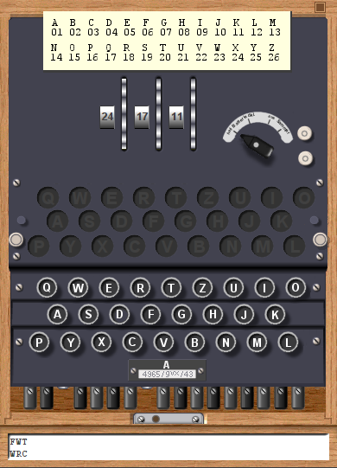
Screen 10. Enigma Simulator in Use.

The sending station is WN; the receiver is F7Z, the time is 1340, and there are 38 characters in the message. Only if the receiving Enigma is set up exactly the same as the transmitting one, will it produce the correct message key, and because only three characters are coded, breaking it is nearly impossible. (Although some lazy operators reused keys, and the British made use of this.) The transmitter now resets the rotors to FWT and encodes the message, in this case, “Preserve wildlife. Pickle a squirrel.” Note that there are no number, punctuation, or space keys. Words will be run together, and we'll use X to end sentences, as did the Germans. If there were digits, we would have to spell them. A complete encrypted message appears below. As is customary the letters shown as five-letter code groups, and they were sent this way via Morse code.

F7Z DE WN 1340 = 49 = XPH WRC =
RTXXF GXBZV GNOVX VFMKK GIXMT SEFLM IVUFW IMG.

The first code group shows which codebook setting was used. (Note the column “Kenngruppen” in Screen 6.) The operator chooses one of the entries for that day and prepends two random letters to make a five-letter code group. Although this group is included in the word count, the receiver doesn't enter it. It sets the rotors to FWT and enters the coded message to produce the result, “PRESERVEWILDLIFEXPICKLEASQUIRRELX”. Some punctuation could be represented as letter groups, but we'll skip over that in this quick introduction.

Hopefully, this brief discussion has given you some idea of what the Enigma really did. A few experiments with the simulator will make things much clearer, as will a few minutes spent exploring the Website.

Fortunately for the Allies, the Germans greatly overestimated the strength of their machines. Their primary error was in thinking that its construction was secret, when in fact the allies obtained working Enigma replicas from the Poles in 1939 and captured several during the war. In addition, some operators, especially in the Luftwaffe, were careless or poorly trained, and this allowed the British in particular to deduce codebook settings and changes in the equipment. Finally, many services used the same codebooks, and some, such as trawlers who were providing weather information in the North Atlantic, were vulnerable to capture.

The U.S. rough equivalent of the Enigma was the m-209, although it was known to be much weaker, as the Germans could decode its messages in about four hours. It was thus used only for tactical communications; strategic information was encrypted using other means. The m-209 was smaller (about 3 x 5 x 7 inches) than the Enigma, did not need a battery, and printed its output on paper tape, making it usable by only one operator. Besides being cryptographically weak, it was tedious to configure and slow to use. Despite these drawbacks, it was used through the Korean War and well into the 50s. Like the Enigma, you can buy models of the m-209, but a better approach is to experiment with a simulator from the same Website that has the Enigma simulator. Screen 11 shows the simulator view that an operator would see while using it.

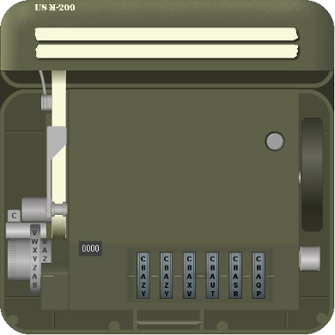
Screen 11. m-209 Crypto Machine.

Characters are entered by twisting the knob at lower left until the desired letter is opposite the index (A in this case). Then the black lever on the right is pressed. This advances the six rotors (visible at the bottom) and prints the output letter on paper tape (to the right of the input wheel). The simulator displays two tapes at the top; the upper one is a record of the input characters, and the lower one the output. The current output character is also visible just to the right of the input wheel (Z in this case). There is also a character counter (here showing 0000), and a round button to reset the machine. Finally, just above the input wheel is a tab marked C, showing the machine is in encrypt mode. This must be flipped to D for decoding.

You can get a hint of how tedious it is to set up the m-209 from its internal view, Screen 12.

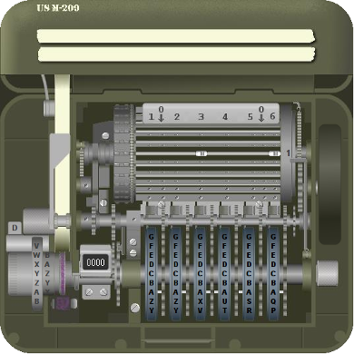
Screen 12. m-209 Crypto Machine Interior.

If you look carefully at the rotors, you can see small pins in the A row. Think of a pin to the right as a one and a pin to the left as a zero. The A row thus is set to 111001. However, setting the rotor pins is only part of the configuration. There are also 27 bars, each with two sliders that must be set. Here Bar #1 has been set to 36. Screen 13 shows a complete setup, typically used for one day.

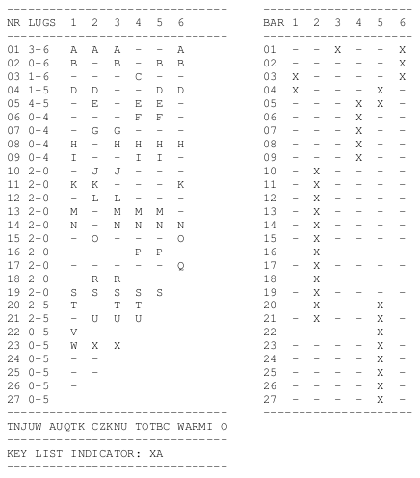
Screen 13. m-209 Configuration Table.

If a letter appears, the pin in that row should be to the right (or set to 1); a dash indicates that the pin should be to the left (or set to 0). Note that rotor 1 has 26 letters, rotor 2 has 25, rotor 3 has 23, rotor 4 has 21, rotor 5 has 19, and rotor 6 has 17. The LUGS column shows the slider positions on each bar, and the table on the right also shows this, but in a different form. It's a real credit to our soldiers that they were able to perform this intricate configuration under combat conditions. I need several tries to do it at home, in an easy chair, with soft music and a cup of coffee.
When complete, the operator would set the rotors to AAAAAA and encode 26 As. If correctly set up, the result should be the 26-letter sequence below the tables. Every configuration was assigned an indicator (XA for this one) that was attached to the encrypted messages, and the receivers used this to be sure that had their equipment properly configured.

Because it's so tedious and repetitive, I won't go through a configuration. Download and run the simulator if you want to experience this. I do think it will be helpful to run through encoding and decoding a message. For this, assume the machine is configured as described above. Like his German counterpart, the American soldier had to generate message key, and he used a similar procedure, encrypt the message and include an encrypted version of it with the message. Only if the receiver has an m-209 with the identical configuration can he recover the key to decrypt the message.

Again, we'll send the message, “Preserve wildlife. Pickle a squirrel.” We choose CVQIMK, set the rotors to it and encode SSSSSSSSSSSS to produce IDJWE PNWFW XU, which will be our key. Our message will include both CVQIMK and SS, so the receiver can generate the same message key. Why 12 characters when we need only six? Recall that most of the rotors have fewer than 26 characters. In this case, when we go to set the machine, we'll find there is no W on rotor 4, so we'll just skip that letter. As a result, the actual key will be IDJEPN. The Americans replaced every space with a Z, but had no standard for punctuation. (If every sentence ended with “PERIOD,” it would aid those trying to break into the messages.) We'll just eliminate the periods in this simple example. Our input becomes PRESERVEZWILDLIFEZPICKLEZAZSQUIRREL, and produces FFBAE CPDXI ALQEG FGYEM MTCBR AMUDJ RQTNC. However, we have to add SS CVQIMK XA, where SS shows the letter we used to produce the key, CVQIMK is the setting to produce the key, and XA is the setup. We'll regroup these 10 letters to SSCVQ IMKXA, because encrypted messages always appear as five-letter code groups. We'll also repeat this important information at the end of the message. Thus, the complete message becomes the following.

SSCVQ IMKXA FFBAE CPDXI ALQEG FGYEM MTCBR AMUDJ RQTNC SSCVQ IMKXA

The receiver uses an identical procedure to develop the message key. That is, he sets his rotors to CVQIMK and encodes SSSSSSSSSSSS to produce the message key. He too has to discard a W. He then flips the code/decode tab to D and enters the encrypted message. Screen 14 shows the result.

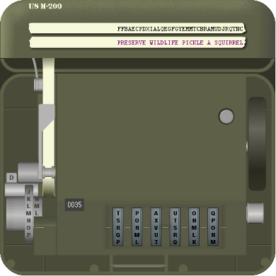
Screen 14. m-209 Simulator in Use.

Note that the m-209 has replaced Zs with spaces. They would also be replaced in such words as “zero,” but this would be evident from the content.

A little experimenting with these simulators will reward you with a better understanding of the difficulties of communicating securely before the computer age.

